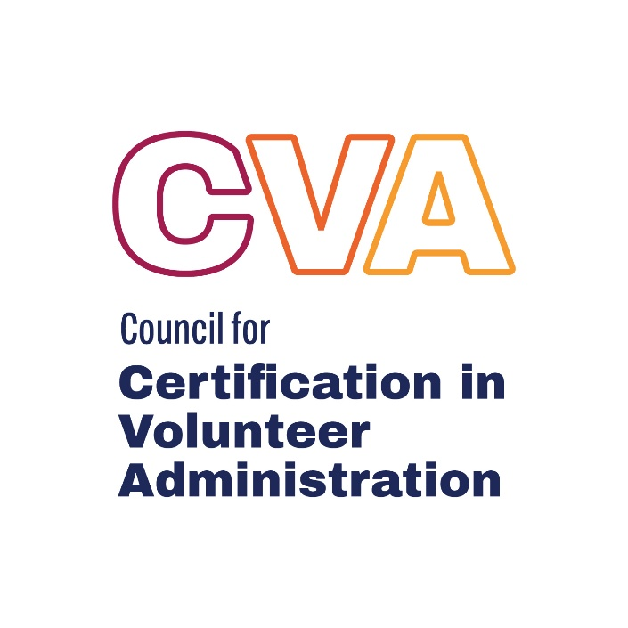

2024-2028 CVA RENEWAL GUIDELINES
Video explanation available HERE.
Option B - CONTINUED COMMITMENT TO VOLUNTEER ENGAGEMENT

PURPOSE OF RENEWAL
In the constantly changing contemporary work environment, the standard of practice in volunteer resource management must remain relevant and effective. Professionals in all fields are expected to be up-to-date in their chosen area of expertise. Employers and communities alike have high expectations of the services provided by certified professionals.

The purpose of the CVA renewal process is to enhance continued competence of CVAs by requiring documentation of learning, reflection, and participation in activities related to this volunteer engagement and leadership. The specific requirements outlined here are designed to:

- include a full range of activities that are relevant today
- provide a balanced approach between passive “head learning” and “experiential” activities
- respond to specific suggestions from past CVA renewal candidates
- provide reflection, flexibility and meaning for the required written component
- emphasize the importance of professional ethics

Renewal of the CVA credential is required every five years to retain the right to use the professional credential, CVA (Certified in Volunteer Administration.) These guidelines explain the specific requirements and acceptable forms of documentation.

GOVERNANCE OF THE CVA RENEWAL PROGRAM
The CCVA Board of Directors approves all policies, based on recommendations from the CVA Renewal Task Force. CCVA reserves the right at any time and without notice to vary the content previously announced and to modify as appropriate to maintain program quality.

RENEWAL CYCLES
The 5-year renewal cycle starts with the notification of the CVA award. While your credential is valid until December 31st of your fifth year in holding the credential, CVAs have until December 1st in the year their credential expires to complete the renewal requirements. Your expiration date is listed on the CVA Registry at https://cvacert.org/cva-registry/

During any five-year renewal cycle, it is the responsibility of the CVA to maintain current contact information including an email address with the CCVA staff. This ensures you receive reminder notices, updates, and other communications which may affect your credential.

WHEN TO APPLY FOR CERTIFICATION RENEWAL
CCVA will send a minimum of two email reminders during the year in which you are due to renew your CVA credential. While you may submit your renewal packet anytime during that year, it is recommended that you not wait until the last minute.

The renewal deadline of December 1st is firm, and there is no grace period. However, based on extenuating circumstances a certificant may appeal the expiration of his/her CVA status. Appeals must be made in writing within 60 days of the expiration date.

CVAs who do not renew their credential or who do not meet renewal requirements may no longer use the “CVA” designation. Their status will be shown as “EXPIRED” in the CVA database and they will no longer appear on the registry. Lapsed CVAs wishing to reinstate their CVA status must successfully complete the entire certification process again.

RENEWAL FEE
Renewal fees may change over time, for the year 2024 the renewal fees are as follows:
Early Bird Fee $150 for renewals sent in from January 1 to May 31.
Regular Fee $200 for renewals sent in by June 1 to December 1.

The fee may be paid by credit card on the CCVA website.

NOTIFICATION OF RENEWED STATUS
CCVA will process your application within 30 days of receipt, and promptly notify you regarding your
renewal status.

SUBMISSION OF RENEWAL APPLICATION
The following documents must be submitted electronically through the Renewal Form on the CCVA
website at https://cvacert.org/certification/#renewal-process

- Cover sheet
- Tracking form and documentation
Professional reflection

COMPONENTS OF RENEWAL SUBMISSION

Part One - Personal Reflection
- All renewing CVAs are required to write a professional reflection essay of 500-750 words. You may select one of 4 topics to write about. (See below)

Part Two –Continued Commitment to Volunteer Engagement
- CVA renewal is required every five years counted from the year you were first awarded your CVA.

- Activities and hours may not be carried over from one renewal cycle to another.

- During the 5-year period you must have at least 24 (twenty-four) months of volunteer management experience

- 80 (eighty) hours of Continued Commitment to Volunteer Engagement through participation in a variety of activities beyond the requirements of your position/job. Activities performed as a core responsibility or expectation of your regular job may NOT be included.

  - A minimum of 40 (forty) hours must be in professional development. The balance can be any combination of Professional Development and Voluntary Service.

  - It is a CVAs responsibility to maintain records documenting PDU or hours activity. You should retain appropriate evidence of this activity; examples of acceptable documentation options are provided and must be submitted at the time of renewal.

CVA RENEWAL PART 1 - PERSONAL REFLECTION

Select one of the following topics to address in an essay of 500-750 words:

TOPIC A - DIVERSITY, EQUITY, AND INCLUSION
What does diversity, equity and inclusion mean to you and how has this been reflected in your volunteer management practice over the past five years? How has this evolved throughout your career in volunteer engagement? Describe any efforts you have made in ensuring equity in access to volunteerism and opportunities for volunteering?

TOPIC B - FAILING FORWARD
Describe an experience of failure that you have had in your volunteer management practice over the past five years. In this failure, what went right?

Things to consider in your response are:
What could you have done differently to achieve a better result? What actions did you take to grow from this experience? How will you put this learning into practice in your work in volunteer engagement in the future? How will you put this learning into practice to change the outcome the next time?

TOPIC C - ADVOCACY
The field of volunteer management has struggled to gain acceptance as an important professional element of volunteer-engaging organizations. As the holder of the CVA credential, explain the role that advocacy has played in your professional practice over the past five years.

Things to consider in your response are:
What have you learnt when advocating? How have these learnings impacted your future interactions? How do you advocate for the profession, especially in environments that are not supportive? How do you encourage other volunteer management professionals to advocate for themselves, their projects and their profession?

TOPIC D - DISRUPTION & INNOVATION
To move our organizations and communities from the status quo towards being more resilient, just, and responsive, we must be both disruptive and innovative in our volunteer management practice. Describe a time during the past five years when you worked to accomplish these goals.

Things to consider in your response are:
How was your project successful and unsuccessful? Which of your efforts helped accomplish these goals and how did your efforts not work out? What mechanisms and relationships did you utilize, which helped accomplish your project? What mechanisms, that were outside of your influence, helped and hindered this project?

There are two ways to submit your reflection:

WRITTEN FORMAT:  - Include your name and the topic you have selected at the top of the page  - Word count must be 500 – 750 words  - Double-spaced, with a 12-point font size  - Correct spelling and grammar  - Must be submitted in PDF format  - Upload your PDF with your renewal where indicated | AUDIO or VIDEO FORMAT:  - Read your name and the topic you have selected at the beginning of your submission  - Minimum 5 minutes, maximum 10 minutes in duration  - Ensure audio is clear and easy to hear  - Graphics and visuals unnecessary, but welcome  - Upload your file as an unlisted link on YouTube and submit the link with your renewal where indicated

POTENTIAL USE BY CCVA: CCVA may occasionally recommend that a personal reflection (or portion of)
be used publicly to demonstrate the value of certification. If your personal reflection is selected, you will
be notified to request your permission prior to use by CCVA.

CVA Renewal Activity Tracking Form For 2024-2028
Option B - CONTINUED COMMITMENT TO VOLUNTEER ENGAGEMENT
The following worksheets are to be used to record your professional development activities for the purposes of renewing your CVA credential.
  - Each sheet is divided into sections that must be fully completed for each professional development activity.

  - A cover sheet is also provided which must be used in addition to the tracking forms.

  - The cover sheet and forms may be completed by hand or by computer.

  - You only need to complete the sheets which are applicable to you. You may add rows if needed. There is no need to submit sheets with categories where you have no hours to track.

  - When completed, upload the relevant sheets of your tracking form as part of your Renewal Application.

IMPORTANT TO NOTE
Retain a copy for your files.
Please send specific evidence of hour activity to CCVA.

CVA RENEWAL COVER SHEET

Name:

Title and Organization:

Preferred Mailing Address (we recommend using a personal address):

Preferred Email Address (we recommend using a personal email):

Preferred Phone Number (we recommend using a personal number):

Renewal Fee:
□ check has been mailed
□ credit card payment on the CCVA website
Personal Affirmation:
I affirm the information submitted is accurate and meets the renewal requirements of the CVA credential sponsored by CCVA.
I re-commit to uphold the principles of Professional Ethics in Volunteer Administration.

_____________________________ ____________________
Print name or Date
include signature above

Hours Summary:
- During the 5-year period you must have at least 24 (twenty-four) months of volunteer management experience

- 80 (eighty) hours of Continued Commitment to Volunteer Engagement through participation in a variety of activities beyond the requirements of your position/job. Activities performed as a core responsibility or expectation of your regular job may NOT be included.

- A minimum of 40 (forty) hours must be in professional development. The balance can be any combination of Professional Development and Voluntary Service.

Please record the total number of hours you have earned in each professional development and voluntary service category below.

Professional Development:
Professional Development may be obtained in one or any combination of the following: continuing education on topics that are directly related to volunteer engagement/resources management (workshops, courses, conferences); independent study (virtual learning modules, podcast listening, audio books, reading); non- accredited courses and/or accredited, non-academic certification or certificates including leadership programs; academic courses and degrees in a field related to volunteer administration; and public speaking, teaching, or consulting in volunteer resources management.

How is this achieved?
A minimum of 40 hours are required during the current five year renewal cycle (that’s 8 hours per year!).

What is the documentation to submit? Acceptable documentation may include a certificate or email statement of attendance by the sponsoring organization, or an attendance form signed by the presenter. Registration confirmations and receipts of payment are not acceptable.

For non-accredited courses, accredited non-academic certification, and/or academic courses or degrees proof of participation and successful completion provided by the sponsoring organization or academic institution (e.g. a certificate, an email statement from the organization or your supervisor, or an attendance and successful completion form signed by the presenter).

For activities of independent study (virtual learning modules, podcast listening, audio books, reading) a written submission no longer than 500 words which details: the topic, a brief synopsis, the total time spent, and what learnings can be applied to engaging volunteers. Use the chart provided below.

For public speaking, teaching and consulting a letter or email from the organization, academic institution, or community served during the role that includes the topic and number of hours served is acceptable documentation.

CVAs are also required to complete the renewal documentation form for each professional development activity.

For each activity being noted, CVAs will fill out the chart below.

Date(s) | Brief Explanation of activity | #of Hours | What I learned that I can apply to my volunteer engagement practice.

Voluntary Service:
CVAs are required to participate in volunteer or community service activities separate from any paid positions they may hold. Direct participation as a volunteer is an excellent way to understand the challenges and opportunities that volunteers face and it enables CVAs to make more informed decisions on matters affecting volunteers when they have real life experiences to draw upon.

How is this achieved?
This Includes service on boards, executive committees and other governance bodies as well as direct service and episodic volunteer activities.

Note that all volunteer/community service must be separate from any paid positions held and conducted in a formal capacity (i.e. with a registered organization).

What is the documentation to submit?
Acceptable documentation is one or more reference letters from the leader of volunteers, supervisor, colleague, client or volunteer who can attest to the CVAs volunteer involvement. The letter should include a date, the author’s relation to the CVA, and how many hours the CVA volunteered during the current certification cycle.

For each activity being noted, CVAs will fill out the chart below.

Date(s) | Brief Explanation of Volunteer Role | #of Hours

Volunteer Engagement Experience
At the time of renewal, CVAs must demonstrate that they have been engaged in leading volunteers, leaders of volunteers or communities in a paid or unpaid capacity during the last five (5) years.

How is this achieved?
At least 24 months of volunteer engagement experience where it was at least 30% of your role.

What is the documentation to submit?
Acceptable documentation is one or more reference letters or emails from a supervisor, colleague, client or volunteer who can attest to the CVAs ongoing practice in volunteer engagement. The letter should include a date, the author’s relation to the CVA, how many months/years the CVA has practiced volunteer engagement during the current certification cycle.

